Diamond Marking System – Transmission LED PCB Requirements

Diamond Marking System 1.0

OPSY_SP00019

Drafted: D Black

Approved:

Issue: 1

Date: 15/01/2021

Revision History:

|  |  |  |  |
| --- | --- | --- | --- |
| **Revision** | **Date** | **Initial** | **Change Notes** |
| 1 | 15/01/21 | DB | Version 1. |
|  |  |  |  |
|  |  |  |  |
|  |  |  |  |

Contents

1 Introduction 3

2 High Level Requirements 5

3 Example IO Interface and connectors 6

4 Software API Example (RS232) 6

Operation Modes: 6

Continuous Mode (EnableTriggerMode = 0): 6

Trigger Mode (optional feature): 6

5 Mechanical Requirements 7

6 Original Circuit Diagram for Reference 8

# Introduction

Opsydia’s diamond marking system requires directional transmission illumination from below the transparent substrate with a relatively small aperture. A comparison of a number of LED’s demonstrated the Broadcom **ALMD-CY3G-YZ002** to be the most suitable source for the application. An simple 5 x 5 LED PCB board was designed to be positioned below a tray of 25 stones. This board was designed with the LED rows and columns connected to and driven by a PLC using pulse-width modulation (PWM). Using the PLC to drive the LED’s has not been reliable with the duty cycle setting never working quite as expected. It also places a requirement for the system to incorporate a PLC with PWM capability. Its far more desirable for the LED driver components to be incorporated on the PCB itself, or within a separate module that plugs into the PCB with direct communication to the PC.

This document describes such a revision of the LED PCB to remove the PWM requirement on the PLC and simplify and reduce the amount of wiring on the system. The system contains an Industrial PC running Window 10 IoT Enterprise and has several RS232 ports and USB ports available. For context, the current LED PCB is shown in figure 1 below.

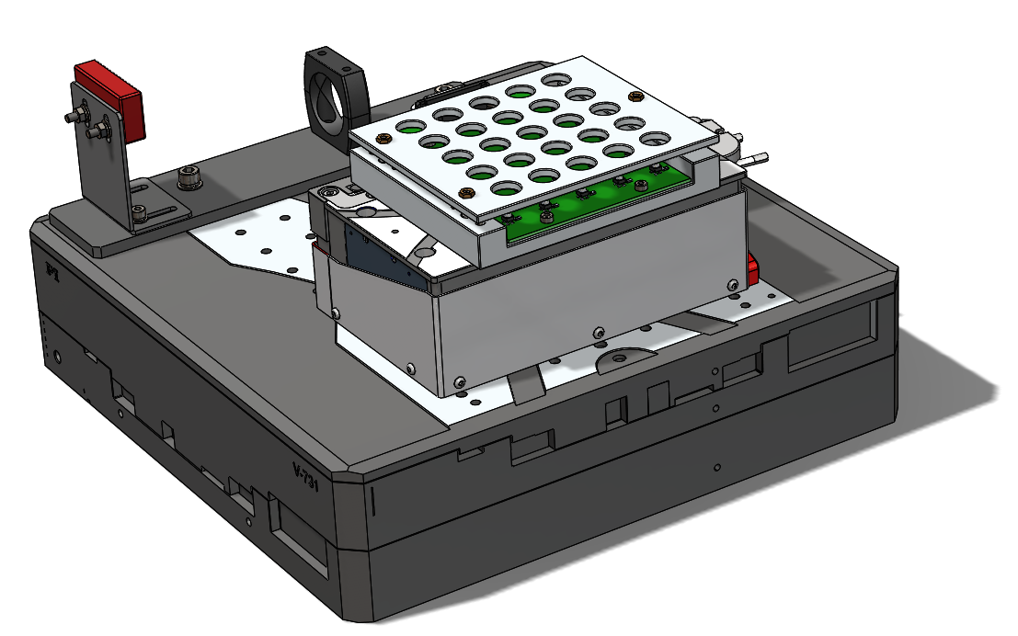

Figure : Front image showing current LED PCB installed below a cassette tray of 25 stones on a XYZ stage stack.

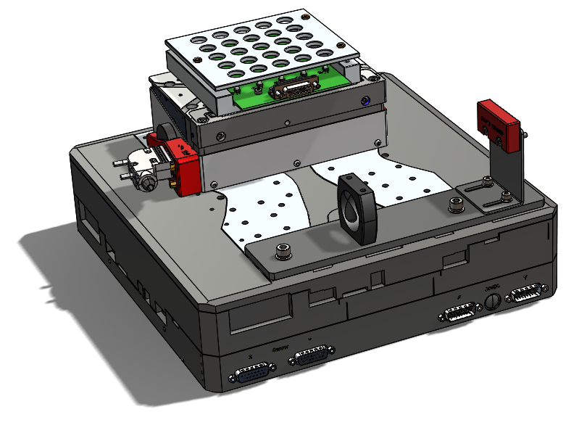

Figure : Rear image showing current LED PCB installed below a cassette tray of 25 stones on a XYZ stage stack.

A concept is proposed in which a RS232 serial interface is used with a microcontroller to drive the LED’s. Another is proposed where an I2C LED driver module is used with a USB to I2C converter installed on the board. The RS232 module is preferable although a cost comparison would be of interest. The engineer designing the circuit should use the IO and API examples presented as guidelines and design the PCB as they best see fit.

# High Level Requirements

|  |  |  |
| --- | --- | --- |
| **#** | **Requirement** | **Comment** |
| 1 | LED’s have the same brightness and beam aperture/directionality as our current PCB LED board. |  |
| 2 | It’s possible to control the LED board by connecting it to a PC and does not require PLC or external electronics. |  |
| 3 | The PCB dimensions, securing holes and placement of the LED’s matches the current LED board version. |  |
| 4 | The board can accept a flash signal input and Trigger the selected LED’s for a specific period. The delay between the signal and the LED’s coming on is settable over the software API. | Not Essential |
| 5 | It should be possible to supply the power to the LED’s using a separate Input to the control electronics. This will make it possible for the safety system to turn off the LED’s without the controller turning off. This was identified as a hazard in the risk assessment given how bright the LED’s are. |  |
| 6 | The LED drive circuit should be isolated from the controller to mitigate risk to the PC. |  |
| 7 | The controller should be programmed and programmable with accessible software (ie, preferably use something like an ESP32 or an MBed OS on an arm chip. We don’t want to have to have a license for expensive software just to make modifications to the board). All source code is required as part of the delivery. |  |
| 8 | Operate in a dry but possibly humid environment with temperatures ranging from 10 to 40 degrees Celsius with nominal operating temperature of 22 degrees Celsius. |  |
| 9 | Incorporate 25 Broadcom **ALMD-CY3G-YZ002** LED’s spaced in a square 5x5 array at a pitch of 20mm in the correct locations regarding the mechanical requirements. |  |
| 10 | Only 1 LED is required to be on at a time. |  |
| 11 | The LED board exists on XYZ stage stack which is moved during the process. The connectors and cable options should be suitable for use in this environment and compatible with an IGUS E-Chain. |  |
| 12 | Cable distance between the PC and LED driver is estimated to be 3m or less but running alongside other power and communication cables. This should be taken into account as to what protocol is used between the PC and PLC. Eg, it may be desirable to have a USB to RS232 module on the PCB and use a USB interface however, if RS 232 is less susceptible to noise then the board should have an RS232 interface. |  |
| 13 | The designer should advise on cables. |  |

# Example IO Interface and connectors

A table of example IO connections is provided but is by no means the required connectors. The engineer designing the circuit should specify what he/she recommends and requires for their design.

|  |  |  |
| --- | --- | --- |
| **#** | **IO** | Connector |
| **1** | Control & RS232 GND Pin 1 | A |
| **2** | LED GND Pin 2 (Should be same GND as Pin above but need a second connection to ensure low resistance for RS232 control signals) | B |
| **3** | Control V+ in (5V) | A |
| **4** | LED V+ in (24V) | B |
| **5** | RS232 TX | A |
| **6** | RS232 RX | A |
| **7** | Trigger Signal In ( 5V) Configurable to rising or falling edge by jumper) | B |
| **8** | USB or JTAG Connector (for updating firmware and debugging only) | C (usb micro) |
| **9** | Jumper to disable/ground the Trigger Signal. | N/A |

The designer may decide that a module exists and would meet the purposes with less effort. For example the NXP PCA9685 chip provides 16 PWM outputs configurable over an 12C bus and is designed specifically for driving LED display devices. One or two of these modules combined with a USB to I2C chip may suffice and remove the need for one to program it. The sync signal would be the only lacking requirement but if this design is far cheaper and one could have an IO to switch the LED’s then the pulse control could be implemented in that in the future.

# Software API Example (RS232)

The LED board should have the following parameters readable and modifiable though the RS232 Interface.

|  |  |
| --- | --- |
| **Parameter** | **Value Range** |
| LED Row | 0-16 (binary mask) |
| LED Col | 0-16 (binary mask) |
| Duty Cycle | 0 – 100 |
| Enable (illuminates or not) | 0 or 1 (True or False) |
| EnableTriggerMode (*) | 0 or 1 (True or False) |
| Trigger Width (us) | 0 – 2000000 (2 seconds) |
| Trigger Delay (us) | 0 – 1000000 (1 second) |

## Operation Modes:

### Continuous Mode (EnableTriggerMode = 0):

In continuous mode the selected LED or (LED’s) are continuously on at the desired duty cycle.

### Trigger Mode (optional feature):

Trigger mode essentially enables the board to be used as a camera flash function. When Trigger mode is enabled, the selected LED will be off, and the board will wait for a rising edge on a hardware interrupt pin (hardware interface Trigger Signal In). Once it receives the signal it’ll wait for the Trigger delay using a hardware timer and then power on the LED at the selected duty cycle for the duration of the Trigger Width.

The ability to reboot/reset the board with a command.

The API should be simple and robust. Something along the lines of the following

|  |  |
| --- | --- |
| PC Sends: “LEDROW=2” | Board Responds with: “OK” or “Error,1” (1 is the error code) |
| PC Sends: “?LEDROW” | Board responds with: “2” |
| PC Sends: “RESET” | Board responds with: “OK” |
| PC Sends: “DUTYCYCLE=80” | Board responds with: “OK” |
| etc… |  |

A comprehensive error code table must be included.

# Mechanical Requirements

A PDF drawing (OAA5700-REV 02.pdf) will be provided alongside this document. The board should fit within the bounds of the current board and use the same mounting holes. Its critical that the LED array is positioned in the same location relative to the mounting holes. If more area is required, the LED board could be lengthened slightly on the connector side. The connectors must be mounted on top of the board with the cable protruding out the side as shown in the following diagram.

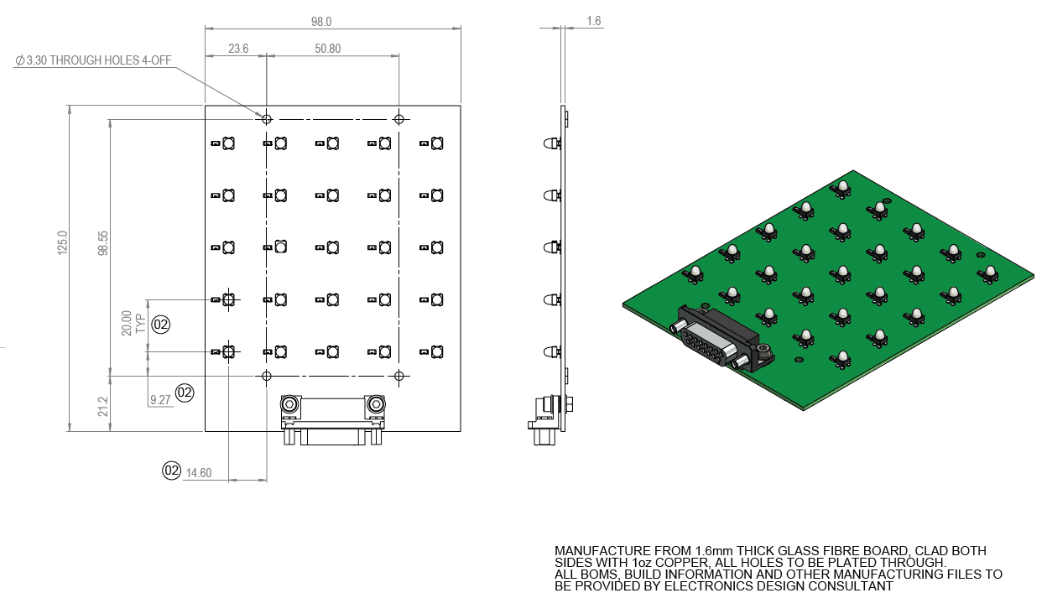

Figure 3: Dimensional requirements of LED PCB.

# Original Circuit Diagram for Reference

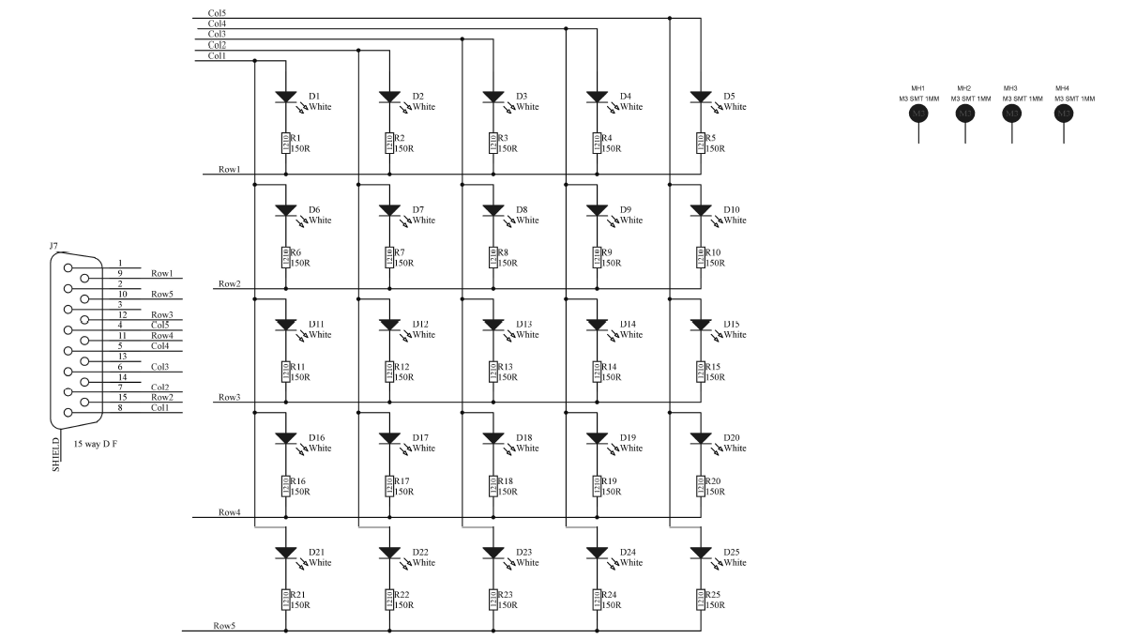

Figure : Circuit diagram of current LED board that is driven by the PLC.